Day 19 Judges I (Deborah, Gideon, Samson): Readings Judges 1-2; 4-8; 14-16
Overview of Judges https://www.youtube.com/watch?v=kOYy8iCfIJ4 (7:29)

A Basic Outline of the Book of Judges
I. Israel’s Failure to Complete the Conquest (1:1-2:5)

II. Cycles of Apostasy, Judgment, and Deliverance (2:6-16:31)
A. The Pattern of Israel’s Apostasy (2:6-3:6)
B. Cycles: “The Israelites Did Evil in the Eyes of the Lord” (3:7-16:31)
1. Othniel (3:7-11)
2. Ehud (3:12-30)
3. Shamgar (3:31)
4. Deborah and Barak (4:1-5:31)
5. Gideon and His Family (6:1-9:57)
6. Tola (10:1-2)
7. Jair (10:3-5)
8. Jephthah (10:6-12:7)
9. Ibzan (12:8-10)
10. Elon (12:11-12)
11. Abdon (12:13-15)
12. Samson (13:1-16:31)

III. The Extent of Israel’s Depravity (17:1-21:24)
A. Idolatry among the Danites (17:1-18:31)
B. Civil War: Levite’s Concubine and Israel against Benjamin (19:1-20:24)

IV. Conclusion: “Everyone did as he saw fit” (21:25)

The Book of Judges is historical narrative, but its primary purpose is to provide religious evidence for the view expressed in Deuteronomy: obeying the Lord brings life and freedom, but disobedience and sin, especially worshipping ‘other gods,’ brings political oppression and death. Judges suggests in general terms that many Israelites struggled to remain faithful to Jehovah alone.

The central portion of the book names twelve judges (the number is not likely a coincidence), six “major” ones, about whom there are exciting narratives, and six so-called “minor” judges, about whom we get little more than an archival-type notation a few verses long. The four primary heroes are Deborah, Gideon, Jepthah, and Samson; local leaders who assume power in specific crises and their victories are regional rather than national. They are selected because of their ability rather than their status or lineage.

Key ideas: the cycles of the Judges period; God’s justice and grace; God’s sovereign provision of delivers; Covenant failure by the people, the priests, and the tribal leadership; the role of the Spirit of the Lord.

“The purpose of Judges is to show the failure of the Israelites to keep their part of the covenant. The cycles show how God demonstrated his power and mercy by delivering them time after time after his justice had demanded that he bring punishment. The book shows that neither the leadership of the Judges nor the tribal leadership succeeded in helping the people remain faithful. Instead, the leaders were as bad as the people.”
Hill & Walton, A Survey of the Old Testament, 235

Major message: “How was God working between these covenants, and why were the Israelites not enjoying the blessings of the covenant? The message of the book is that the problem was not the Lord’s fault, but was created and sustained by Israel’s continued disobedience. The Judges period was characterized by acts of depravity, not just individually, but on the tribal level. This is conveyed by the two sets of refrains that recur in their respective sections of the book. Each cycle in chapters 3-16 is introduced by the observation that “the Israelites did evil in the eyes of the Lord” (2:11; 3:7, 12; 4:1; 6:1; 10:6; 13:1), indicating the tendency toward theological apostasy. The second refrain serves as an ‘inclusio’ by appearing at the beginning and end of chapters 17-21 (17:6; 21:25): “In those days there was no king in Israel; everyone did as he saw fit.” The first half of the phrase is used in two places as well to sustain the narrative in between (18:1; 19:1).”
Hill & Walton, A Survey of the Old Testament, 240.

Historical Background of Israel
The two centuries following the Israelite settlement in Canaan (ca. 1220-1020 B.C.) are designated the period of the judges, as outlined in the biblical book of the same name. These “judges ,” including Ehud, Deborah, Gideon and Samson, are mainly depicted as military leaders for different Israelite tribes or combinations of tribes, not as judicial or political officials, as in the Book of Mormon. The Bible indicates that these judges were chosen by the Lord to lead Israelites in military action to deliver them from subjection to various neighboring peoples. This subjection, attributed to Israelite unfaithfulness, produced repentance and appeals for deliverance, inducing Jehovah to provide judges to assist in freeing Israel. Generally, a period of peace was followed by another slide into apostasy and the pattern would repeat itself (e.g., Judg. 3). While the Israelites were connected through genealogy and religion, the book of Judges mentions no national political organization in Israel during this time. Kinship provided a major means of organization in this patriarchal society: tribes, clans, extended families. Although annual holidays were celebrated at the tabernacle, legitimate prophets and priests receive little mention in the book of Judges. The main religious challenge for the Israelites of this era was the lure of Canaanite deities, especially Baal and Asherah. Most Israelites did not totally abandon the worship of Jehovah, but many corrupted it with concepts and practices borrowed from the Canaanites and by worshipping other deities in addition to Jehovah. Although some Israelites were involved in military, religious, or mercantile occupations, the vast majority of Israelites were engaged in the subsistence occupations of agriculture and animal husbandry, a situation that continued throughout the biblical era.
Dana M. Pike, “Israel, Historical Background of,” in Dennis Largey, ed.,
Book of Mormon Reference Companion (2003; Deseret), 409-410.

Trying to understand Israel’s Apostasy
“Reading the book of Judges, one wonders how the Israelites could have gone so wrong. The Lord prepared their escape from Egypt by means of the plagues, parted the sea before them, gave them his law at Sinai, sustained them in the wilderness, and brought them into the land of Canaan and settled them here. How could they just turn their backs on all that and worship other gods?. . .

“[First], the prophets inform us that even in the wilderness the Israelites worshiped other gods (Amos 5:25-26; Jer. 7:25), and we have no reason to assume that monotheism was practiced during the four hundred years in Egypt . . . .
Second we must recognize that the difference between the monotheism commanded at Sinai and the polytheism of the ancient Near East involved much more than the number of deities. Monotheism offered a whole new perspective on deity. In this system God is the ultimate power in the universe. He is not subordinate to anyone or anything. He does not manifest himself in natural phenomena, though he controls all of nature. He is moral and consistent and expects behavior that is moral and just. He is autonomous and therefore cannot be manipulated by cultic ritual.
In contrast, the Israelites were still seeped in the old religious concepts. The Canaanite religion is observable in tablets found in the port city of Ugarit from the time of the judges. Each god had its respective sphere of influence and was subject to the decrees of the assembly of the high gods. There likewise existed a power above the gods that could be appropriated by the gods and, to a lesser extent, by men and women through divination. These gods were often connected with and manifested through the forces of nature. They were capricious and unpredictable and not particularly prone to moral behavior. Their demands were largely ritual in nature, and it was thought that the temple and sacrifice satisfied their needs. And since they had needs that were dependent on humans to provide, the gods could be manipulated.
These two view of deity—Israelite monotheism and Canaanite polytheism—were mutually exclusive. The monotheistic view that was accepted in theory at Sinai involved sophisticated philosophical adjustments that most of the people simply never made. Once the Israelites had arrived in the land and had scattered to their respective territories, the ever-present Canaanite religion influenced the way they thought about God. Not only did they worship the Canaanite gods, but as even the prophets indicated at a much later date, they treated the Lord as if he were on of the pagan deities.”
Hill & Walton, A Survey of the Old Testament, 245-56

Major Features of Canaanite Religion
Pantheon: Like other ancient Near Eastern peoples, the Canaanites were polytheistic, believing in and worshipping a number of deities, especially ones conceived of as having power over life, fertility, rain, and warfare. The chief Canaanite deity was El. Ugaritic texts depict El as the old, wise, creator god. At Ugarit, Athirat/Asherah was the consort of El and, as such, the mother of the gods. In Canaan she was associated with lion and tree imagery. A stylized wooden tree or pole was one of her symbols in Israel. Due to these associations, the Septuagint, followed by the KJV, rendered the Hebrew noun ‘asherah as “grove(s)” (e.g Deut 7:5; Judg 6:25). The Bible and Israelite inscriptions indicate at least some Israelites worshipped Asherah and probably conceived of her as Jehovah’s consort. Baal was the Canaanite storm god, associated with lightening and rain and thus with fertility. There are numerous biblical references to Israelites worshipping Baal.

Religious Practices: Functionally similar to the Israelites in some ways, the Canaanites prayed to their gods, celebrated holy days, built temples, had priest, offered animals and agricultural sacrifices (their sacrificial terminology shares similarities with that in the Hebrew Bible), burned incense, and practices various forms of divination to determine the will of the gods. . . .
Canaanites worshipped Baal and other deities at “high places” as well as at formal temples. A “high place” (Hebrew bamah) was a local, often open-air, shrine near a city; it had an altar, priests, and other cultic features, such as standing stone and an ‘asherah (a symbol of Asherah). The Israelites worshipped Jehovah at their own high places for much of their history in the land of Israel (e.g. 1 Sam 9:19, 25; 1 Kings 3:3-5), but king Josiah eventually shut these down for religious and political reasons (2 Kings 23:5-9). Thus, a high place was not inherently “bad.” It depended on how it was used. . . .
The use of idols and figurines to represent deities was common throughout the world of the Old Testament, including Canaan. Visual depictions of El, Baal, Asherah, and other Canaanite deities have been discovered. The presence of female figurines at Israelite sites is usually considered evidence for the Israelite worship of Asherah, although a few scholars view these as ‘prayers in clay,’ a female figure symbolizing the desire for fertility and lactation (and thus a type of sympathetic magic), but not representing a deity.
Holzapfel, Pike, and Seely, Jehovah and the World of the Old Testament (2009), 167-68.

Canaanite God Baal
BAAL (Heb. baʿal) DEITY. The Canaanite storm- and fertility-god. As an epithet for various West Semitic deities, especially Hadad, the name means “lord,” designating a legal state of ownership or social superiority. With the obvious exception of Yahweh, Baal is the most significant deity in the OT. In a land [Canaan] dependent upon rain-fed agriculture, the storm-god is the most significant deity in the culture. Baal does serve as the most powerful god of the Canaanite pantheon, though his progenitor El is its head. Further, the cult plays a major role in the daily and ritual lives of societal members, given the paramount need for rain and its continuous impact upon the population.
Eerdmans Bible Dictionary (2000), s. v., “Baal”.

Asherah (Hebrew: ʾăšērâ or ʾasherah)
The Hebrew name of an Amorite or Canaanite goddess and the cult object dedicated to her. A complete distinction between the deity and the sacred poles erected in her honor is not always possible in the OT (cf. Judg. 3:7). …
The Ras Shamra [Ugaritic] texts portray her (Ugar. ʾaṯrt) as the spouse of the supreme god El (sometimes called Elat, “goddess”) and the mother of 70 children, including Baal (perhaps also a consort); she is also called “Lady Asherah of the sea.” In the Baal cycle she intercedes with El to provide a palace for Baal. Asherah was the mother goddess, to be distinguished from Astarte, the Canaanite fertility goddess. Centers of worship were located throughout the ancient Near East, particularly Phoenicia. Manifestations of Asherah worship have been identified in Egyptian, Hittite, Philistine, and Arabic texts.
Hebrew ʾăšērâ refers not only to the goddess but also to the consecrated poles, called either Asherah (e.g., Deut 16:21; Judg 6:25, 28) or Asherim (e.g., Exod 34:13; Deut 7:5; 12:3), which represented the deity. At first they may have been living trees (cf. Deut. 16:21; possibly a sacred grove [thus the translation of ’asherah as “grove, groves” in the KJV]), but in later usage were wooden poles, perhaps stylized to represent a tree (cf. 2 Kgs 17:10). These poles may also have been carved images of the goddess. Remains of what are believed to be such poles, including those discovered among Bronze Age finds at Shechem, consist mainly of postholes in which the rotted timber has left a differently colored soil.
In ancient Israel worship of Asherah is attested at local shrines during the period of the judges (Judg 3:7-8). Both Jeroboam I of Israel (1 Kgs 14:15) and Rehoboam of Judah (v. 23), sons and successors of Solomon, fostered Asherah worship in their respective kingdoms. When King Ahab married the Phoenician princess Jezebel, worship of Asherah was strongly promoted in the northern kingdom, together with the worship of Baal. The prophet Elijah counted some 400 of her prophets (and 450 of Baal) eating at Jezebel’s table (no doubt supported by the queen; 1 Kgs 18:19). Israel’s devotion to Asherah is cited as a cause for its deportation to Assyria (2 Kgs 17:10, 16).
Allegiance to the Asherah cult was proscribed (Exod 34:13-14; Deut 7:5), and various attempts were made to eradicate the practice (e.g., Gideon, Judg 6:25-30). … [emphasis added]
Eerdmans Bible Dictionary (2000), s. v., “Asherah.”

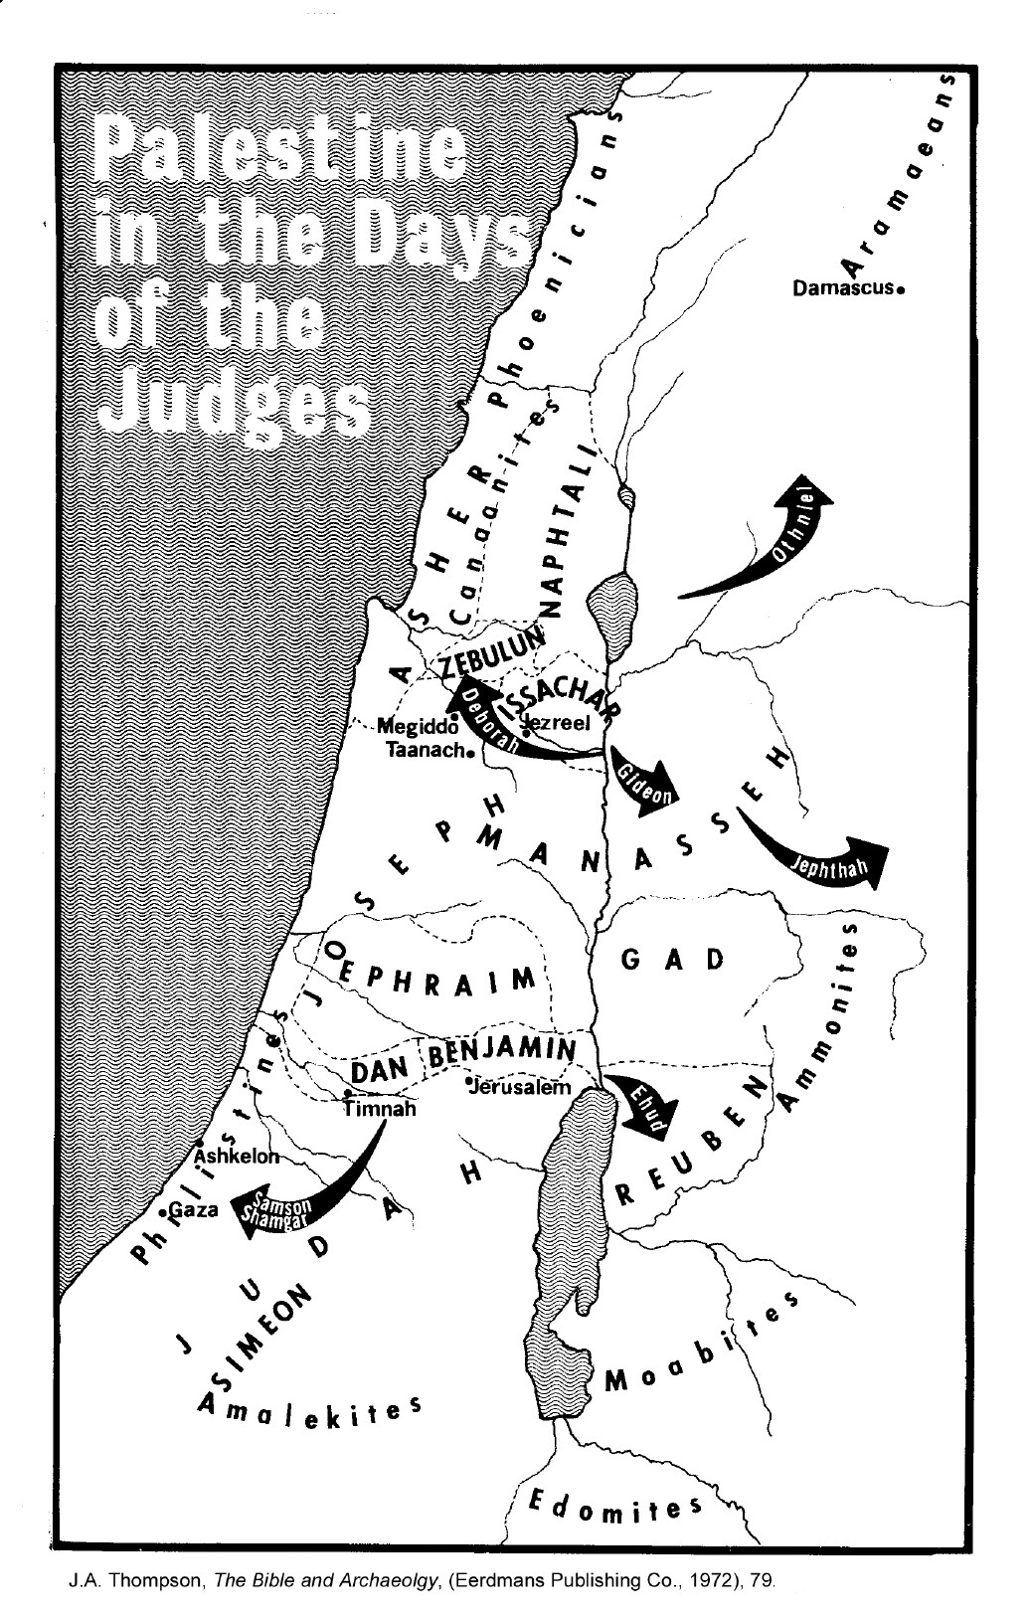

The Cycle Pattern in Judges

 | *The names of the so-called “major” judges are printed in bold font.
Othniel | After 8 years of oppression from King Cushan of Aram, Othniel went to war and delivered Israel. | 40 years
Ehud | After 18 years of oppression from King Eglon of Moab, Ehud killed Eglon, went to war against Moab, and was victorious. | 80 years
Shamgar | Shagmar killed 600 of the Philistines with a poking device used to move animals along. | Unknown
Deborah | After 20 years of oppression from King Jabin of Canaan, Deborah convinced Barak to attack. Barak was victorious. | 40 years
Gideon | After 7 years of Midianite oppression, Gideon defeated the Midianites with only 300 men, using trumpets and jars. | 40 years
Tola | The son of Puah son of Dodo from the tribe of Issachar. He lived in Ephraim. | 23 years
Jair | A man from Gilead who had thirty sons who rode thirty donkeys, and they had thirty towns in Gilead. | 22 years
Jephthah | After 18 years of Ammonite oppression, Jephthah delivered Israel after making a vow with the Lord. | 6 years
Isban | Isban was from Bethlehem. He had thirty sons and thirty daughters. | 7 years
Elon | Elon was from the tribe of Zebulun. | 10 years
Abdon | Abdon, son of Hillel, had forty sons and thirty grandsons who rode on seventy donkeys. | 8 years
Samson | A Nazarite with superhuman strength. Killed 1000 Philistines with a jawbone. Destroyed a Philistine temple. | 20 years

